WE NEED YOUR HELP – TELL US WHAT INTERESTS YOU

Now that the Covid restrictions are behind us, Neerim District Landcare is wanting to restore its community activities, workshops and information sessions.

For more than 25 years, Neerim District Landcare has initiated local community action and learning programs targeting the four core Landcare themes:

- Sustainable Farming
- Land management
- Pest plant and animal control
- Support for local wildlife

The group has a simple purpose – to encourage a sustainable, integrated approach to agriculture and the environment in our region.

Our goal is to build capacity in our community to better manage the land and water assets that sustain us by developing and implementing programs that are practical, deliverable and community focussed.

We want your help, by telling us, what areas and topics are of interest to you.
This will assist us to provide relevant and interesting activities, guest speakers and information on topics of local importance.

To submit your preferences, to request further information or to register your interest in participating please complete the details over the page and return to:

info@ndlg,com.au
or
PO Box 68
Neerim South. 3831

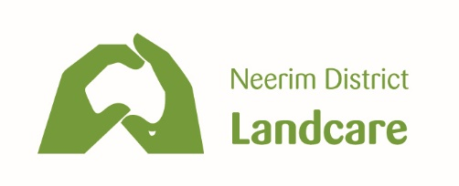
PLEASE TICK THOSE ITEMS YOU MAY BE INTERESTED IN LEARNING MORE ABOUT
BIODIVERSITY
- Native bird identification
- Building nest boxes
- Farm walks on properties with high quality biodiversity
- Plant identification
- Threatened species
- Monitoring water quality on your farm

LAND MANAGEMENT
- Benefits of shelterbelts for farm productivity
- Propagating and/or seed collection
- Farm dam rehabilitation
- Woodlot development

SUSTAINABLE AGRICULTURE
- Soils
- Benefits of multi-species
- Healthy foods – healthy people
- Permaculture

PEST PLANT AND ANIMAL CONTROL
- Pest animal management and control
- Invasive plant management
- Alternative weed management (low chemical)
- Agricultural Chemical Users Permit (ACUP) courses for landowners

NAME …………………………………………………………………..

ADDRESS ………………………………………………………………
………………………………………………………………
PHONE ………………………………………………………………
EMAIL ………………………………………………………………
ANY OTHTER TOPICS OF INTEREST TO YOU

…………………………………………………………………………………………………………………………………………………………

…………………………………………………………………………………………………………………………………………………………….

